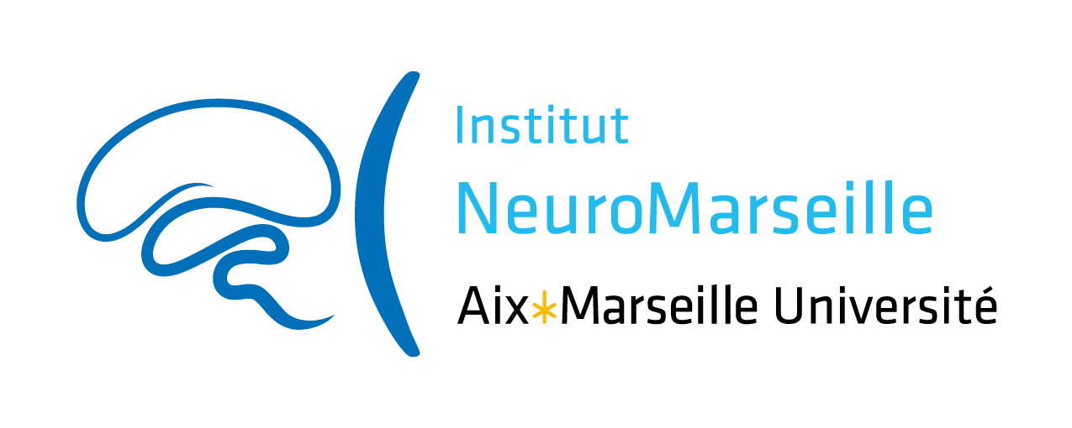

Collaborative “Technical Boost” grant in Neuroscience 2024

TB grant

NeuroMarseille institute wishes to promote scientific exchanges and encourage the emergence of collaborative projects within Marseille’s neuroscience community. The institute constitutes a component of Aix-Marseille University (AMU) supported by AMIDEX funding. The use of funding is therefore governed by AMIDEX financial rules and subject to evaluation.
In this context, NeuroMarseille institute opens this call titled Collaborative “Technical Boost” Grant in Neuroscience, in order to promote collaboration between a researcher (or post-doc or PhD student) and an engineer responsible of a technical platform.
Each project will be granted up to 10 k€ over a period of 12 months.

Eligibility Criteria

Applicants: personnel belonging to research units (UMR) affiliated to NeuroMarseille can answer this call, including: researchers (CR, MCU, DR, Pr, PU), engineers (AI, IE, IR), as well as Post-docs and PhD students. The 2 partners must be affiliated to 2 different UMR.

Research program: the research program must be new and in need of an innovative technical experiment. The evaluated criteria will be: the program feasibility (available equipment, new equipment if needed, personnel involved, etc...), as well as the scientific quality and the innovative nature of the project.

Eligible expenses: a detailed budget must be attached to the project proposal. Eligible expenses include: operating costs and equipment for the platform needed in the context of the project.

Application modalities

Submission: the project submission deadline is November 12, 2023 at 23:59. Applicants must use the Application Form provided by NeuroMarseille.

Evaluation: the Scientific Committee, composed of NeuroMarseille neuroscientists, will evaluate and select the projects. The evaluations will be sent by e-mail to the applicants from the 2nd week of January, 2024.

Terms of engagement: it is mandatory to mention the support of NeuroMarseille in all scientific publications and communications in relation with the project:
This work has received support from the French government under the Programme « Investissements d’Avenir », Initiative d’Excellence d’Aix-Marseille Université via A*Midex funding (AMX-19-IET-004), and ANR (ANR-17-EURE-0029).

The grantees involved in the project will be asked
- to give with their application a brief description of their project for communication purposes
- to send a brief description of the results they have obtained, the objectives achieved and the follow-up envisaged (application for funding, publication, etc…)
  - including a “data management plan” = a short section describing how data have been produced, documented, (re)used, managed and shared during and after the project. It is a tool to help set up a reflection on research data to make it FAIR (easy to Find, Accessible, Interoperable, Reusable, etc.).
- to possibly present their findings during the events organized by NeuroMarseille
- to possibly be part of the next Scientific Committee.

