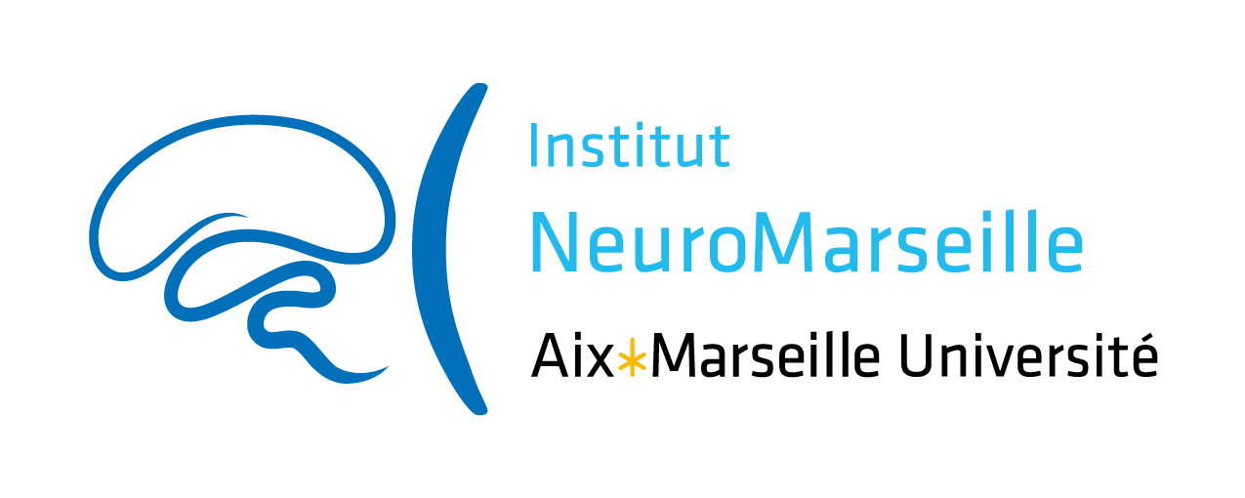

Innovative and Collaborative Research Grants in Neuroscience 2023

ICR and ICR “Plus”

NeuroMarseille institute wishes to promote scientific exchanges and encourage the emergence of new collaborative projects within Marseille’s neuroscience community. The institute constitutes a component of Aix-Marseille University (AMU) supported by AMIDEX funding. The use of funding is therefore governed by AMIDEX financial rules and subject to evaluation.
In this context, NeuroMarseille institute opens this call titled “Innovative and Collaborative Research Grants in Neuroscience”, in order to promote collaboration between people involved in Neuroscience research (see “Applicants” below) willing to start new innovative and high-quality projects.
Each project will be granted up to 20 k€ over a period of 12 months.

In addition, applicants can ask for a budget extension if needed: this “Plus” part, as compared to the ICR grant alone, is aimed at helping a platform involved in the project to invest in new equipment in order to offer new or better tools for the success of the project. This equipment has to be useful for NeuroMarseille users beyond the described project. The “Plus” part of the budget can not be used for consumable.
Each “Plus” project will be granted up to 15 k€ over a period of 12 months.

Eligibility Criteria
Personnel who obtained a NeuroMarseille Collaborative Research Grant in 2022
is not eligible.

Applicants: Personnel belonging to Research Units (UMR) affiliated to NeuroMarseille can answer this call, including: researchers (CR, MCU, DR, Pr, PU), engineers (AI, IE, IR), as well as Post-docs and PhD students.
Projects must involve at least two Partners (researchers/teams/units) who do not belong to the same UMR. In case of a collaboration with one or more partner(s) not belonging to NeuroMarseille, the funding will only be half of the maximum allocation. In case of a collaboration involving 2 NeuroMarseille partners and one or more partner(s) not belonging to NeuroMarseille, the allocation will remain whole.

Research program: The research program must be particularly innovative and should not represent the continuation of an ongoing project. Priority will be given to novelty and innovation; preliminary data are therefore not compulsory. The evaluated criteria will be: the program feasibility (equipment, collaborations, personnel involved, etc...), the scientific quality of the project as well as scientific quality of the participating teams, with a special focus on their complementarity.
Technical program “plus”: The project must demonstrate that the requested equipment will be useful for the project as well as for the neuroscientific community of Marseille.

Eligible expenses: A detailed budget must be attached to the project proposal. Eligible expenses include: equipment, operating costs and undergraduate traineeship grants.

Application modalities
Submission: The project submission deadline is November 06, 2022, at 23:59. Applicants must use the Application Form provided by NeuroMarseille.

Evaluation: The Scientific Committee, composed of NeuroMarseille neuroscientists with the possible support of national experts, will evaluate and select the projects. The evaluations will be sent by e-mail to the applicants from the 2rd week of January 2023.

Terms of engagement: It is mandatory to mention the support of NeuroMarseille in all scientific publications and communications in relation with the project:
This work has received support from the French government under the Programme « Investissements d’Avenir », Initiative d’Excellence d’Aix-Marseille Université via A*Midex funding (AMX-19-IET-004), and ANR (ANR-17-EURE-0029).

The grantees involved in the project will be asked
- to give with their application a brief description of their project for communication purposes
- to send a brief description of the results they have obtained, the objectives achieved and the follow-up envisaged (application for funding, publication, etc…)
  - including a “data management plan” = a short section describing how data have been produced, documented, (re)used, managed and shared during and after the project. It is a tool to help set up a reflection on research data to make it FAIR (easy to Find, Accessible, Interoperable, Reusable, etc.).
- to possibly present their findings during the events organized by NeuroMarseille
- to possibly be part of the next Scientific Committee.

