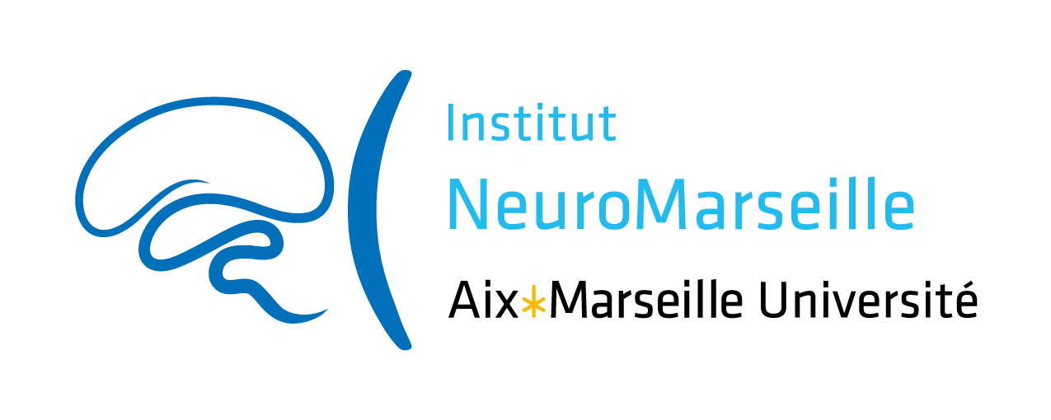

Collaborative Technical Grant in Neuroscience 2021
“CT Grant”

NeuroMarseille institute wishes to promote scientific exchanges and encourage the emergence of new collaborative projects within Marseille’s neuroscience community.
The institute constitutes a component of Aix-Marseille University (AMU) supported by AMIDEX funding. The use of funding is therefore governed by AMIDEX financial rules and subject to evaluation.
In this context, NeuroMarseille institute opens this call titled “Collaborative Technical Grant in Neuroscience”, in order to promote collaboration between a researcher (or post-doc or PhD student) and an engineer responsible of a technical platform.

Each project will be granted up to 20 k€ over a period of 12 months. This amount will be managed by one of the Partners involved in the project, who will be defined by the applicants. Be careful to chose this Partner in charge of the financial gestion in a lab who is financially affiliated to AMU.

Eligibility Criteria

Applicants: Personnel belonging to Research Units (UMR) affiliated to NeuroMarseille can answer this call, including: Researchers (CR, MCU, DR, Pr, PU), Engineers (AI, IE, IR), as well as Post-docs and PhD students.

Research program: the research program can be the continuation of an ongoing project, a technical experiment needed in order to provide a new insight for the global project. The evaluated criteria will be: the program feasibility (actual equipment, new equipment if needed, collaborations, personnel involved, etc...), the scientific quality of the project as well as scientific quality of the participating collaborators, with a special focus on their complementarity.

Eligible expenses: A detailed budget must be attached to the project proposal. Eligible expenses include: operating costs, undergraduate traineeship grants if needed, general equipment and platform new equipment if needed.

Application modalities

Submission: The project submission deadline is December 06, 2020, at 23:59. Applicants must use the Application Form provided by NeuroMarseille.

Evaluation: The Scientific Committee, composed of NeuroMarseille neuroscientists, will evaluate and select the projects. The evaluations will be sent by e-mail to the applicants by the end of the 3rd week of January, 2021.

Terms of engagement: It is mandatory to mention the support of NeuroMarseille in all scientific publications and communications in relation with the project:
“This work was supported by a grant from NeuroMarseille (#AMX-19-IET-004)”
The grantees involved in the project could be asked to present their findings during the events organized by NeuroMarseille.

