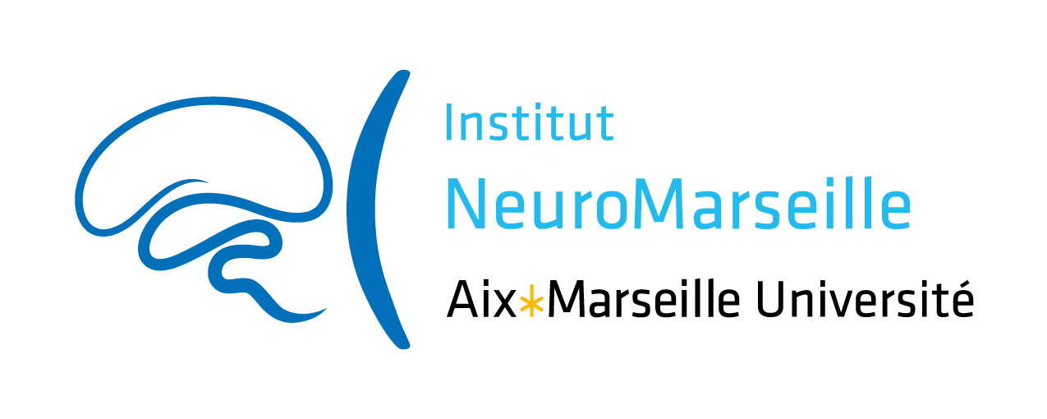

Innovative and Collaborative Research Grant “PLUS” in Neuroscience 2021

NeuroMarseille institute wishes to promote scientific exchanges and encourage the emergence of new collaborative projects within Marseille’s neuroscience community. The institute constitutes a component of Aix-Marseille University (AMU) supported by AMIDEX funding. The use of funding is therefore governed by AMIDEX financial rules and subject to evaluation. In this context, NeuroMarseille institute opens this call titled “Innovative and Collaborative Research Grants “PLUS” in Neuroscience”, in order to promote collaboration between people involved in Neuroscience research (see “Applicants” below) willing to start new innovative and high-quality projects. The “Plus” part as compared to l’ICR grant alone, aimed to help a platform involved in the project to invest in a new equipment in order to offer new tools/ better tools for the success of the project. This equipment definitly has to be usefull for a larger use beyond the described project

Each project will be granted up to 20 k€ for the ICR part and also up to 20k€ for the “Plus” part, over a period of 12 months. This amount will be managed by one of the Partners involved in the project, who will be defined by the applicants. Be careful to chose this Partner in charge of the financial gestion in a lab who is financialy affiliated to AMU.

Eligibility Criteria

Applicants: Personnel belonging to Research Units (UMR) affiliated to NeuroMarseille can answer this call, including: Researchers (CR, MCU, DR, Pr, PU), Engineers (AI, IE, IR), as well as Post-docs and PhD students.
Projects must involve at least two Partners (researchers/teams/units) who do not belong to the same UMR. In case of a collaboration with one or more partner(s) not belonging to NeuroMarseille, the funding will only be half of the maximum allocation. In case of a collaboration involving 2 NeuroMarseille partners and one or more partner(s) not belonging to NeuroMarseille, the allocation will remain whole.
Partner 1 (see Application Form) will be the applicant and will be responsible for managing the allocated budget, and must belong to NeuroMarseille.
Personnel/team who obtained a NeuroMarseille Collaborative Research Grant in 2020 is not eligible.

Research program: the research program must be particularly innovative and should not represent the continuation of an ongoing project. Priority will be given to novelty and innovation; preliminary data are therefore not compulsory. The evaluated criteria will be: the program feasibility (equipment, collaborations, personnel involved, etc...), the scientific quality of the project as well as scientific quality of the participating teams, with a special focus on their complementarity.
Technical program “plus”: the project must demonstrate the usefulness of equipping a NeuroMarseille platform with the requested material: usefulness for the project and beyond for the neuroscientific community of Marseille

Eligible expenses: A detailed budget must be attached to the project proposal. Eligible expenses include: operating costs, undergraduate traineeship grants if needed, general equipment and platform new equipment.

Application modalities

Submission: The project submission deadline is December 06, 2020, at 23:59. Applicants must use the Application Form provided by NeuroMarseille.

Evaluation: The Scientific Committee, composed of NeuroMarseille neuroscientists with the possible support of national experts, will evaluate and select the projects. The evaluations will be sent by e-mail to the applicants by the end of the 3rd week of January, 2021.

Terms of engagement: It is mandatory to mention the support of NeuroMarseille in all scientific publications and communications in relation with the project:
“This work was supported by a grant from NeuroMarseille (#AMX-19-IET-004)”
The grantees involved in the project could be asked to present their findings during the events organized by NeuroMarseille.

